Jyaba tech | Nepal  
**Confidentiality Agreement**  
It is understood and agreed to that the below identified disclosure of confidential information may provide certain information that is and must be kept confidential. To ensure the protection of such information, and to preserve any confidentiality necessary under patent and/or trade secret laws, it is agreed that

1. The Confidential Information to be disclosed can be described as and includes: Invention description(s), technical and business information relating to proprietary ideas and inventions, ideas, patentable ideas, trade secrets, drawings and/or illustrations, patent searches, existing and/or contemplated products and services, research and development, production, costs, profit and margin information, finances and financial projections, customers, clients, marketing, and current or future business plans and models, regardless of whether such information is designated as “Confidential Information” at the time of its disclosure.

2. The Recipient agrees not to disclose the confidential information obtained from the disclosed to anyone unless required to do so by law.

3. This Agreement states the entire agreement between the parties concerning the disclosure of Confidential Information. Any addition or modification to this Agreement must be made in writing and signed by the parties.

4. If any of the provisions of this Agreement are found to be unenforceable, the remainder shall be enforced as fully as possible and the unenforceable provision(s) shall be deemed modified to the limited extent required to permit enforcement of the Agreement as a whole.

WHEREFORE, the parties acknowledge that they have read and understand this Agreement and voluntarily accept the duties and obligations set forth herein.

**Recipient of Confidential   
Information:   
Name**: Roshan Bahadur Khadka Chettri (50-01-77-03192)

Signature: 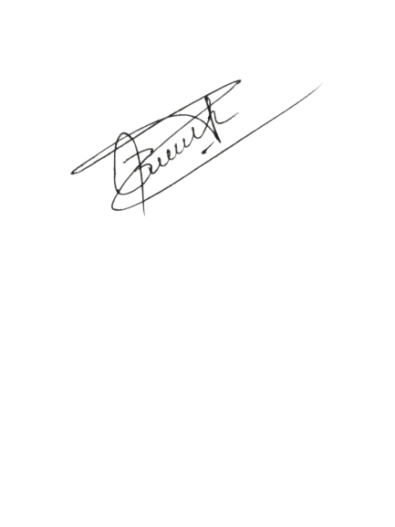  
Date: 2024-07-21

Disclosure of Confidential Information: Name: Jyaba Tech

Tara Prasad Gurung  
Signature:   
Date: 21.07.2024